Assignment 7.6

Write a map reduce program save the output of the word count program in XML format. You need to write a custom writable to save the output in XML format.

CODE :

Driver Class

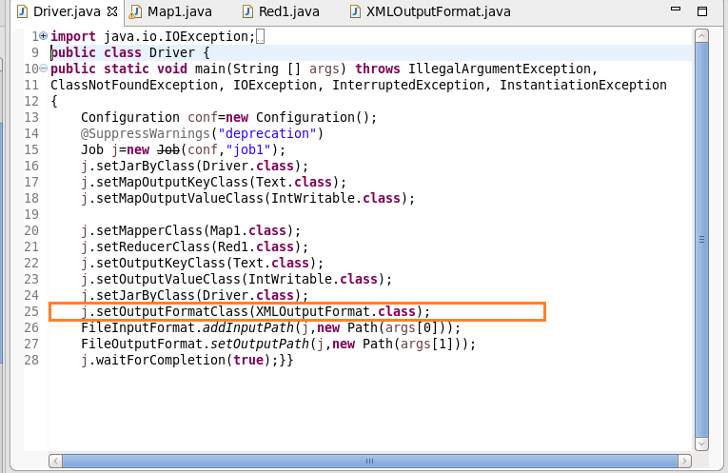

Mapper Class

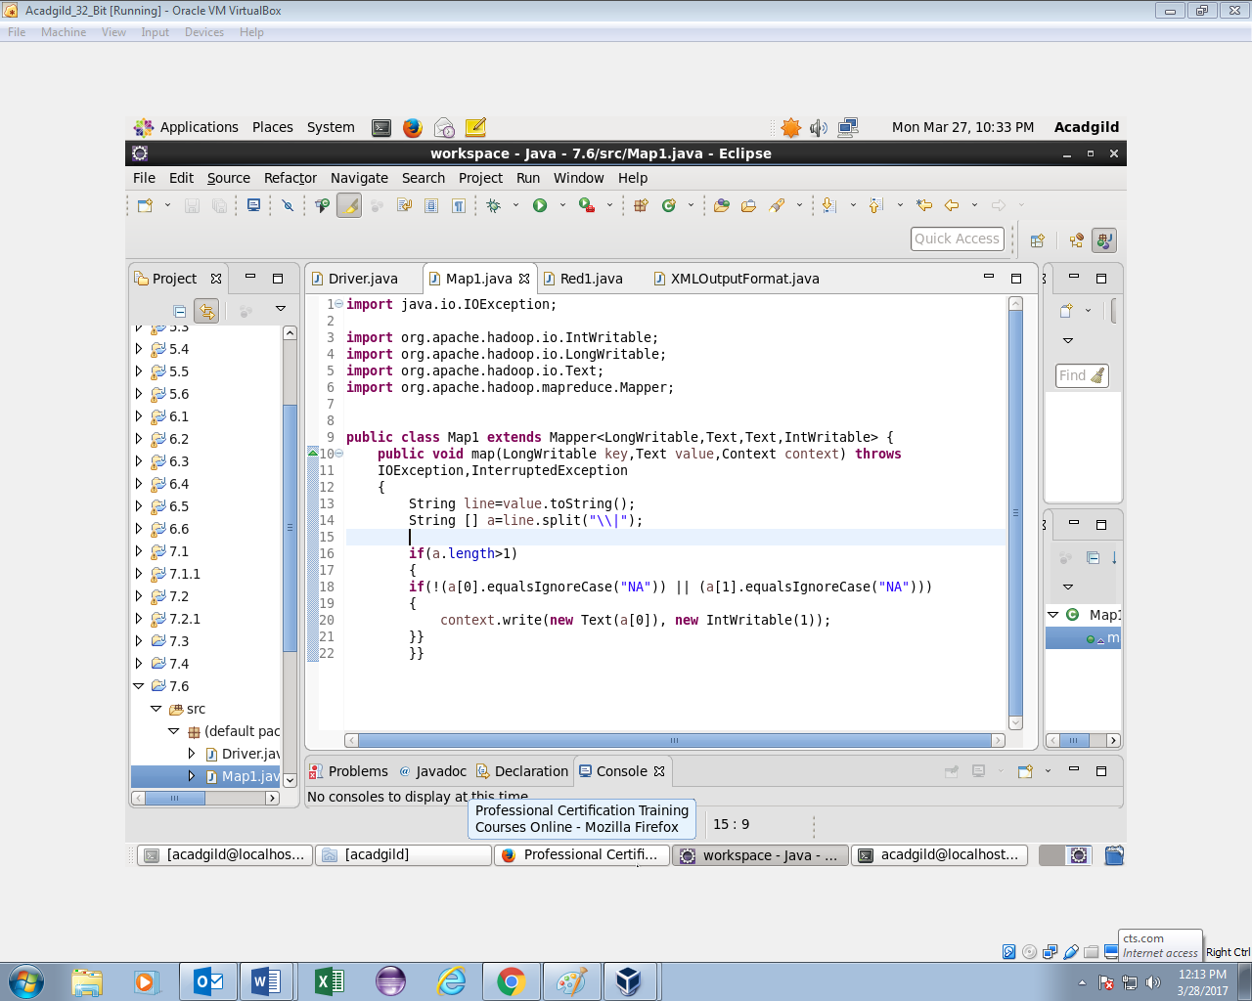

Reducer Class

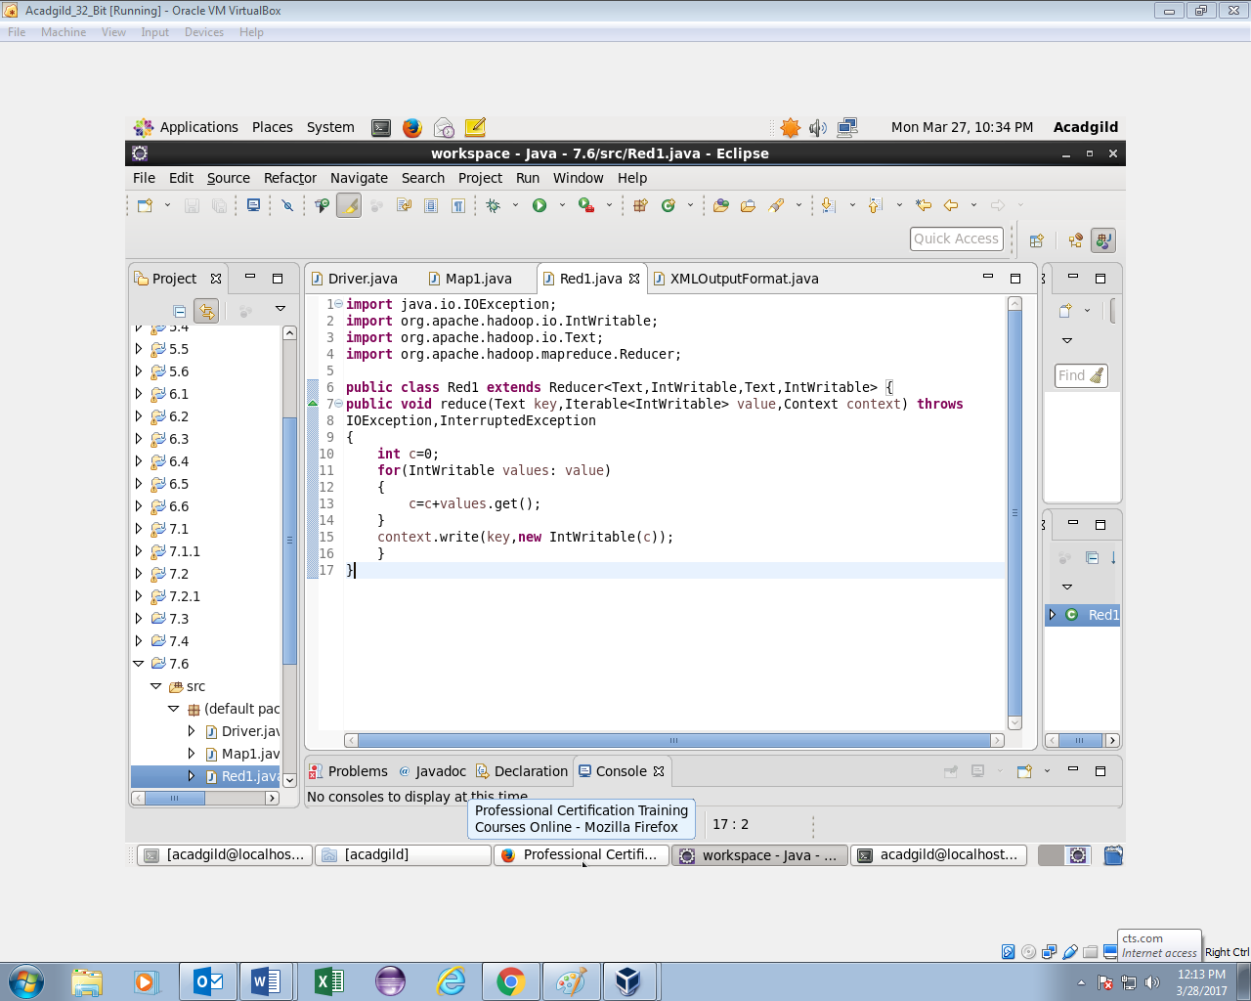

XMLOUTPUTFORMAT Class

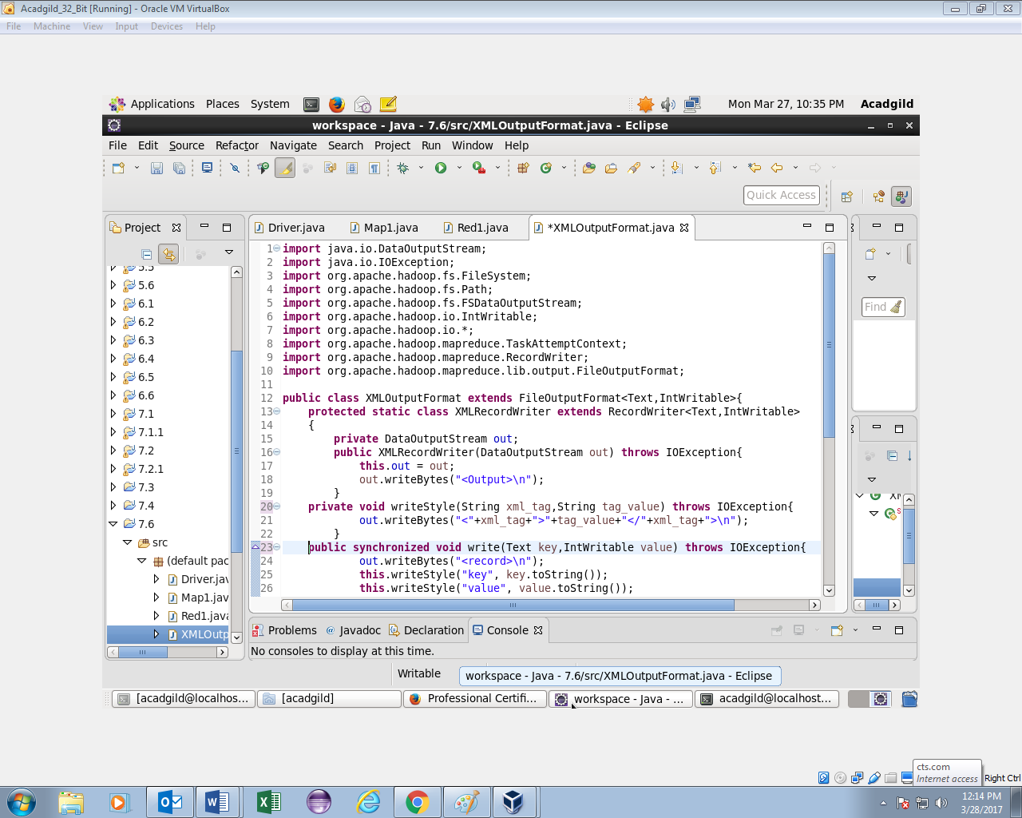 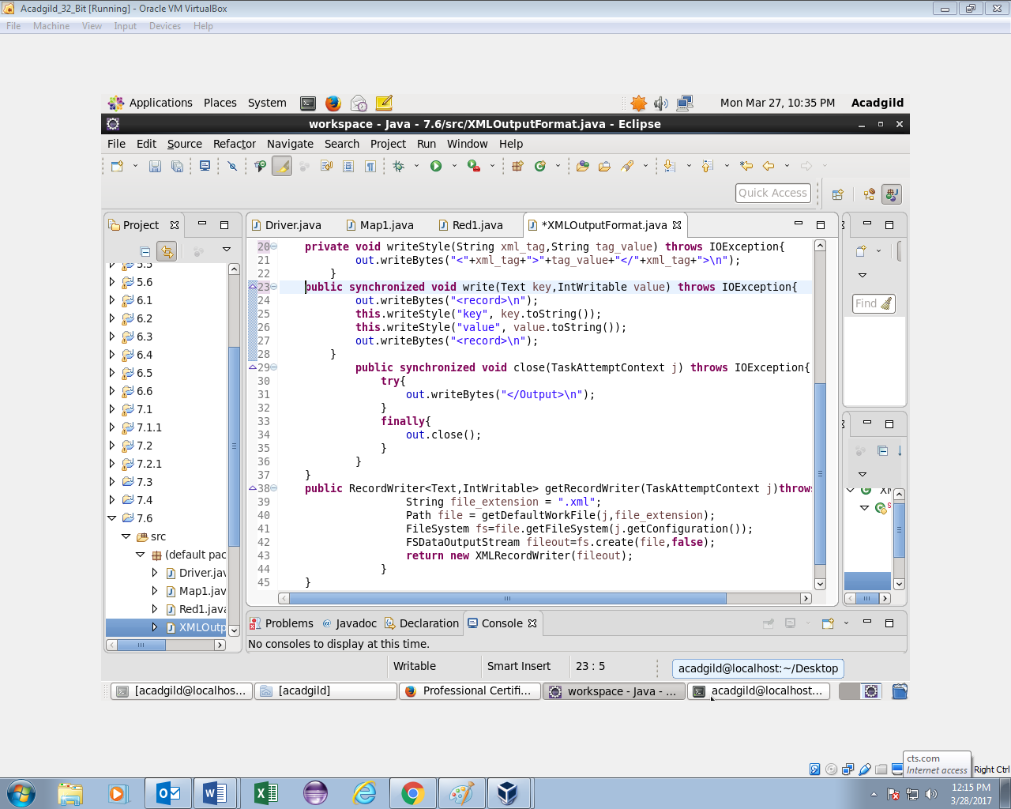

OUTPUT :

